Solutions to Seminar 7

1. a. Earnings = DIV₁ = $4
Growth rate = g = 0
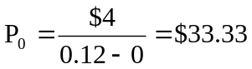
P/E = $33.33/$4 = 8.33
b. If r = 0.10 ⇒ 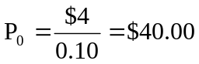 ⇒ P/E increases to: $40/$4 = 10

2. a. Plowback ratio = 0 ⇒ DIV₁ = $4 and g = 0
Therefore: 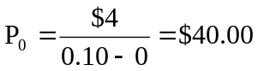 ⇒ P/E ratio = $40/$4 = 10
- Plowback ratio = 0.40 ⇒ DIV1 = $4(1 – 0.40) = $2.40 and g = 10% × 0.40 = 4%
Therefore: 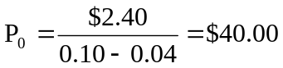 ⇒ P/E ratio = $40/$4 = 10
c. Plowback ratio = 0.80 ⇒ DIV1 = $4(1 – 0.80) = $0.80 and g = 10% × 0.80 = 8%
Therefore: 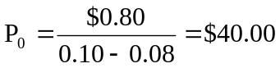 ⇒ P/E ratio = $40/$4 = 10
Regardless of the plowback ratio, the stock price = $40.

3.
DPS = 2; EPS = 4.62. This means that the retention rate, b, is:
b = 1 – (DPS/EPS) = 1 – (2/4.62) = 0.5671

The growth rate:
g = b x ROE = 0.5671 x 0.1185 = 0.0672

The discount rate:
R = D/P + g = 2/99.63 + 0.0672 = .08728 = 8.728%

4- First, we must calculate the earnings per share and dividend. Below is given the range of values for each variable.

 | 1 | 2 | 3 | 4 | 5
ROE | 14% | 14% | 14% | 14%
Payout Ratio | 0.5 | 0.5 | 0.5 | 0.5
EPS | 7.00*1.07=7.49 | 8.01 | 8.575 | 9.176
Dividend | 7.49*0.5=€3.745 | 4.007 | 4.288 | 4.588 | 4.387

The growth rate from year 5 g is 0.2*11.5%=2.3%

To value the shares we must discount the dividends back to time 0. We must also calculate present value of the perpetuity starting in year 5.

End of Year Dividend
 | 1 | 2 | 3 | 4
 | Div₁/ (1 + r)  3.745/ (1.115)  = 3.359 | Div₂ / (1 + r)²  4.007/ (1.115)²  = 3.223 | Div₃ / (1 + r)³  4.288/ (1.115)³  = 3.09 | Div₄ / (1 + r)⁴  4.588/ (1.115)⁴  = 2.967

The growth rate from year 5 is:

g = Retention ratio × Return on retained earnings = .2 x .115 = 0.023

V₄ = 4.387 / (0.115 - 0.023) = 47.684
V₀ = 47.684/ (1+ 0.115)⁴ = 30.85
P₀ = 3.359 + 3.223 + 3.09 + 2.967 + 30.85 = 43.49

5.
a. If the company continues its current operations, it will not grow, so we can value the company as a cash cow. The total value of the company as a cash cow is the present value of the future earnings, which are a perpetuity, so:
Cash cow value of company = C / R
Cash cow value of company = £43,000,000 / 0.1
Cash cow value of company = £430,000,000
The value per share is the total value of the company divided by the shares outstanding, so:
Share price = £430,000,000 / 10,000,000
Share price = £43
b. To find the value of the investment, we need to find the PV of the growth opportunities. The initial cash flow occurs today, so it does not need to be discounted. The earnings growth is a perpetuity. Using the present value of a perpetuity equation will give us the value of the earnings growth one period from today, so we need to discount this back to today. The PVGO of the investment opportunity is:
PVGO = C₀ + C₁ + (C₂ / R) / (1 + R)
PVGO = −£31,000,000 − £33,000,000/1.1 + (£36,000,000 / 0.1) / (1 + 0.1)
PVGO = £266,272,727.27
c.The price of a share of equity is the cash cow value plus the PVGO. We have already calculated the PVGO for the entire project, so we need to find the PVGO on a per share basis. The PVGO on a per share basis is the PVGO of the project divided by the shares outstanding, which is:
PVGO per share = £266,272,727.27 / 10,000,000
PVGO per share = £26.63
This means the share price if the company undertakes the project is:
Share price = Cash cow price + PVGO per share
Share price = £43 + £26.63
Share price = £69.63

Q6
(a)
If the company does not make any new investments, the share price will be the present value of the constant perpetual dividends. In this case, all earnings are paid as dividends, so, applying the perpetuity equation, we get:
P = Dividend / R
P = SEK5.5 /0.14
P = SEK39.29
(b)
The investment occurs every year in the growth opportunity, so the opportunity is a growing perpetuity. So, we first need to find the growth rate. The growth rate is:
g = Retention Ratio × Return on Retained Earnings
g = 0.25 × 0.4
g = 0.1 or 10%
Next, we need to calculate the PV of the investment. During year 3, Twenty five per cent of the earnings will be reinvested. Therefore, SEK1.38 is invested (SEK5.5 × 0.25). One year later, the shareholders receive a 40 per cent return on the investment, or SEK0.55 (SEK1.38 × 0.4), in perpetuity. The perpetuity formula values that stream as of year 3. Since the investment opportunity will continue indefinitely and grows at 10 per cent, apply the growing perpetuity formula to calculate the NPV of the investment as of year 2. Discount that value back two years to today.
PVGO = [(Investment + Return / R) / (R − g)] / (1 + R)²
PVGO = [(−SEK1.38 + SEK0.55 / 0.14) / (0.14 − 0.1)] / (1.14)²
PVGO = SEK49.12
The value of the equity is the PV of the firm without making the investment plus the PV of the investment, or:
P = PV(EPS) + PVGO
P = SEK39.29 + SEK49.12
P = SEK88.41

Question 7
a.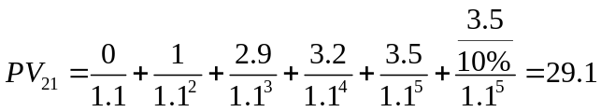

- Assuming no debt, the share price would be:
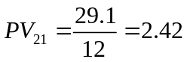
- 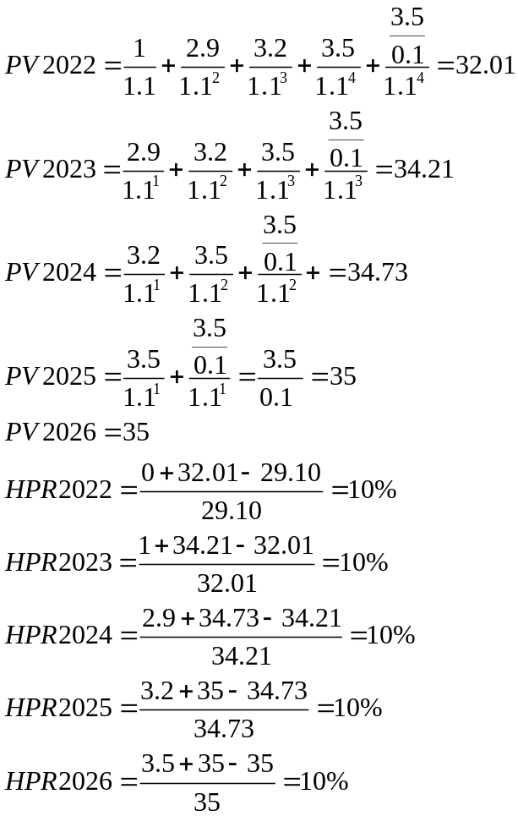
Question 8
Currency amounts are in billions of pesos.
a.
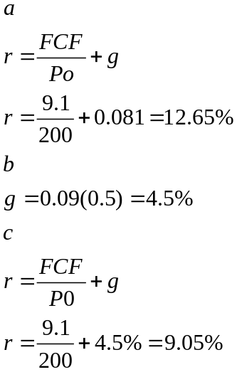
Question 9
- Advantages
  - Optional dividend
  - Gearing considerations
  - Influence over management
  - Extraordinary performance
- Disadvantages
  - High cost
  - Dividends are not tax deductible
Q10
E1 | 750000
N | 10000000
Inv 1 | 500000
Inv 2 & | 0.5 | of earnings
Roe 1 | 0.25
Roe 2&+ | 0.16
r | 0.14
Year | Earnings | Dividends | Plowback | Payoff following years
1 | 750000 | 250000 | 500000 | 125000
2 | 875000 | 437500 | 437500 | 70000
